Assignment 1 Output:

Task: Create a Python module for data logging and use it in a weather data retrieval script.

1. Created directories for code, logs, and data.

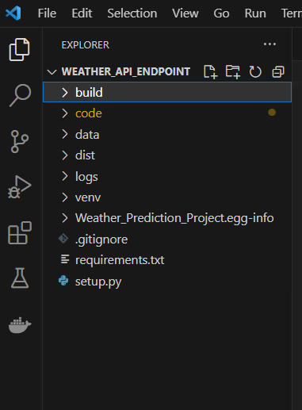

1. Created Config.ini file to store the configuration settings, including the API endpoint and file paths.

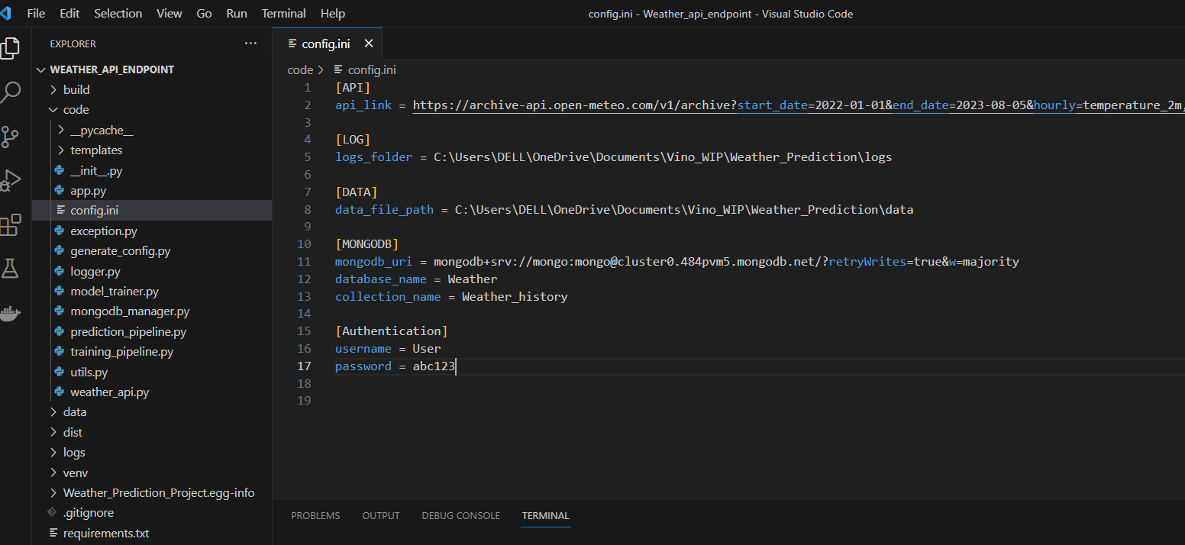

1. Created logger module to log messages to a file in the log’s directory specified in **config.ini**.

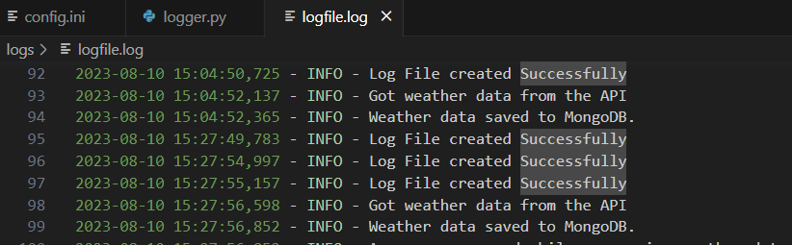

4. Retrieved weather data from open-source weather API

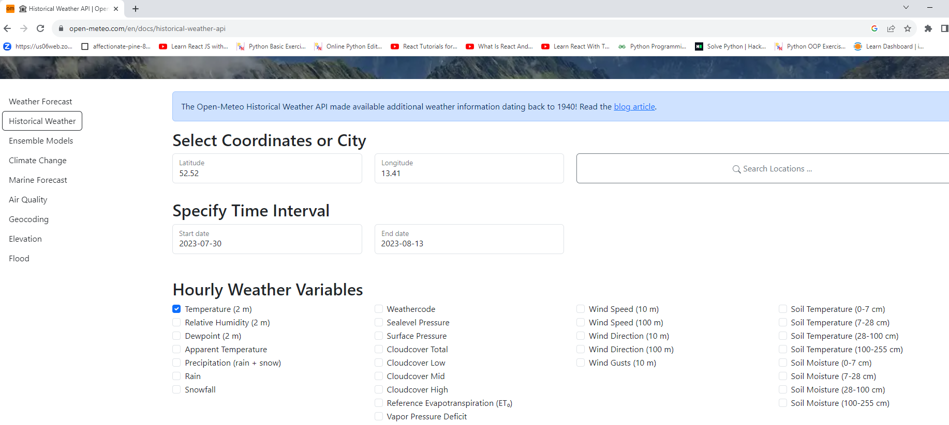

5.Stored the retrieved weather data in a file in the MongoDb

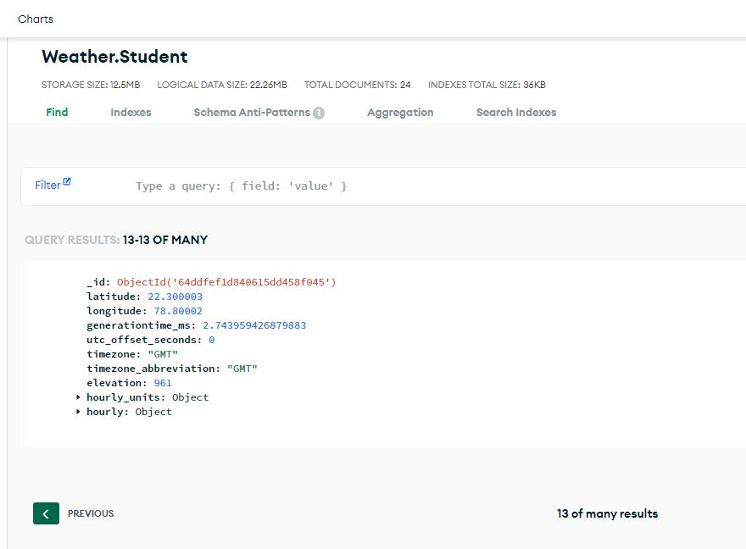

6. Stored the retrieved data from MongoDB to the Json file in the Data directory

